

ELECTRICAL AND ELECTRONICS ENGINEERING

ee463 statıc power conversıon



EMAchines

Ekin Alp BİÇER – Ümit Mert ÇAĞLAR – Asım Reha ÇETİN

INSTRUCTOR: Ozan KEYSAN

LECTURE ASSISTANT: İlker ŞAHİN

Table of Contents

1 INTRODUCTION 2

1.1 Introduction to Power Electronics 2

1.2 Introduction to Project 2

2 DESCRIPTION 3

2.1 Problem Description 3

2.2 Possible Solutions 3

2.2.1 Three-Phase Thyristor Rectifier 3

2.2.2 One-Phase Thyristor Rectifier 6

2.2.3 Diode Rectifier (three phase) + Buck Converter 8

2.3 Solution Approach 9

3 SIMULATIONS 10

3.1 AC-DC Diode Bridge Converter 10

3.2 DC-DC Buck Converter 11

3.3 Overall System Design 12

3.4 Heat dissipation and Heatsinks 15

3.5 Filtering Elements and Protection 15

4 TEST RESULTS 15

5 DEMONSTRATION 17

5.1 Demonstration Experiences 17

5.2 Heating 18

6 EXPANDITURES 18

7 CONCLUSIONS 19

8 REFERENCES 20

9 APPENDICES 20

I. Project Trailer Link (in Turkish) 20

II. Arduino Code 20

# INTRODUCTION

## Introduction to Power Electronics

Power electronics are a relatively new developing electronics area. Basic electronics include inductors capacitors and various transistors; however, these electronics are widely used for low voltage applications. The ability of using them in middle and even high voltages create immense improvement possibilities.

Conventional transformers include large coils with long copper windings, with power electronics we can now build switching power supplies, in which the switching elements are counterparts of low voltage transistors. The main difference of low voltage and high voltage transistors are the immense difference between heat generated due to losses. Even both have very efficient transistor models, the high voltage applications dissipate much higher heat compared to low voltage applications. Although in high voltage applications don’t have as much area limits as low voltage applications, we still need to consider realistic solutions.

There are many professional interest areas in power electronics and one of them is the concept of converters. These converters can be categorized but not limited to AC-DC converters and DC-DC converters, also there are filter elements and gate drive elements that accompany power electronics. Filter elements are much like in high frequency applications but with larger capacitor and inductor components and much less stages (generally only one stage).

## Introduction to Project

In static power conversion hardware project, we are tasked to operate a DC motor, control its speed and work under full load for a certain amount of time. Input side is AC which is delivered to the project setup through an autotransformer (variac). The variac is only used to deliver required amount of AC voltage to the implemented setup. Variac output cannot be changed for driving motor so basically the variac is acting as a fixed transformer which is always the case in industrial designs. From the grid every industrial de

Gate drives are much complicated in power electronics, now we are combining relatively very high voltages and currents and very low voltages and currents. Gate drives such as optocoupler, Arduino microprocessor unit and such require 5-10 V to operate and draw 20-30 mA, while these components operate at these ratings power electronics and motors in the scope of this project are rated with 400-600Volts and 10-20Amperes. Even a fraction of these ratings will cause volatile destruction on gate drive elements.

# DESCRIPTION

## Problem Description

We are tasked to operate the DC motor seen in figure 1 with following ratings as in table 1:

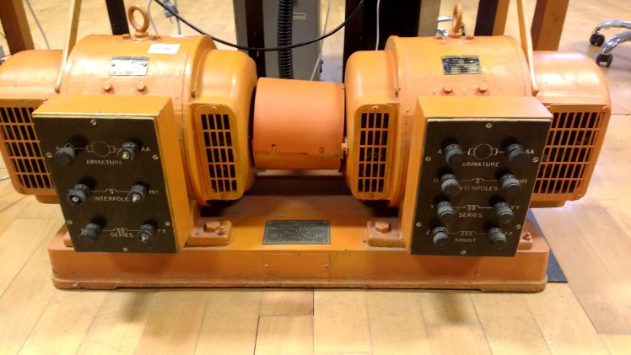

**Figure 1:** DC motor EMAchines aim to drive.

|  |  |
| --- | --- |
| Rate power 2.8 kW | Armature Winding: 28 Ω, 13.3 mH |
| Rated voltage 220 V | Series Winding: 65 mΩ, 260 µH |
| Rated Speed 1500 RPM | Shunt Winding: 8.26 kΩ, 6.4 H |
| Rated Current 12.7 Amperes | Interpoles Winding: 0.8 Ω, 5.8 mH |

**Table 1:** DC motor specifications.

The aforementioned DC motor is to be operated with the grid 400 Vl-l three-phase AC voltage source. The grid and DC motor will be connected through our power electronic project.

## Possible Solutions

### Three-Phase Thyristor Rectifier

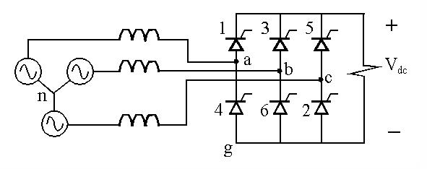

**Figure 2:** Three phase thyristor rectifier.

Three phase thyristor rectifiers, as can be seen from figure 2, are composed of six thyristors. Three phase thyristor rectifiers can be opened with appropriate gate signals to each of their thyristors. These gate signals can also be used to control how much DC output is generated from the AC side. Overall circuit simulation is shown below in figure 3.

Major advantage of using three phase thyristor rectifiers is the ability to control speed by controlling the firing angles of switching elements in the rectifier bridge. However, these switches need to be fired with a fixed delay between them. And this delay creates the requirement of using a zero-crossing detection device. This device (or circuitry) will detect the voltage when it passes zero mark, then an internal counter will count the time required to fire the next set of rectifiers. Due to complexity of this problem as well as the requirement to use complicated circuitry decreased the feasibility.

Although we have agreed not to continue in this topology, we have conducted theoretical study and preliminary simulations on this topology.

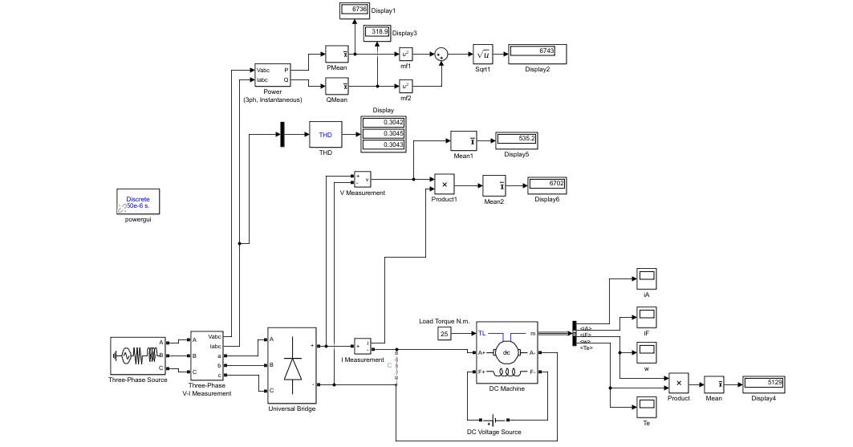

**Figure 3:** Three phase thyristor rectifier circuit.

Since we have decided not to use this topology, only motor current and motor speeds are represented in figures 4 and 5 under constant torque which is 25 N/m. Firing angle is set to zero.

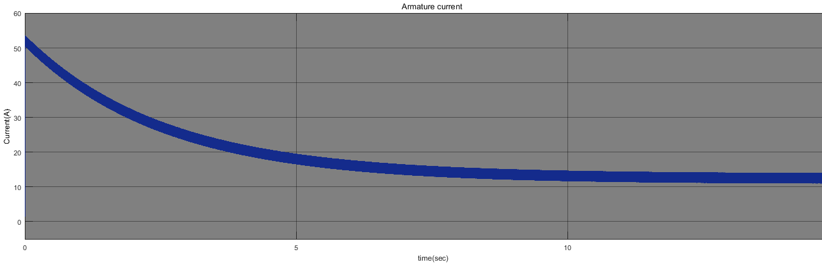

**Figure 4:** Armature current, motor driven by 3 phase full controlled rectifier.

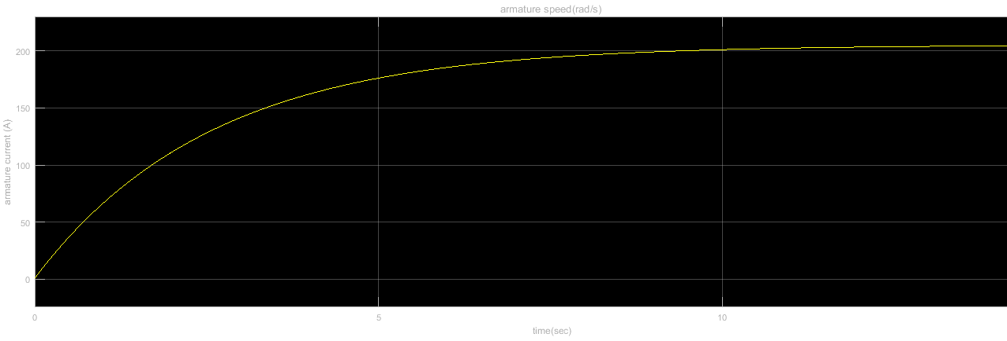

**Figure 5:** Armature speed of motor driven by 3 phase full controlled rectifier.

Input line THD is 0.30 and output of the rectifier circuit is 535 V which can be seen from the figure 1. The results agree with our expectations of a three-phase rectifier. With 230 VAC input we get roughly 540VDC. By adjusting the firing angles, we can control the DC output of this topology. However major drawback of this setup is the requirement to fire each thyristor pair after a certain amount of delay between each other.

We can also use half controlled variation of this topology. In half controlled 3ph thyristor rectifier setup we would have 3 diodes and 3 thyristors where diodes are acting as free wheeling diode which create a return path for storage elements when their pair thyristors are off. Adding diodes like this will increase the overall output voltage with decreasing firing angles.

Also, three phase fully controlled thyristor rectifier topology is easier to output negative voltages. One of main advantages of this topology over diode rectifier + buck converter setup is the ease of creating negative voltages thus operating in other quadrants. As EMAchines, we have concluded that four-quadrant bonus can also be done with H-bridge topology in diode rectifier setup, and the simpler application of diode bridge overwhelms the advantages of three-phase thyristor topologies.

### One-Phase Thyristor Rectifier

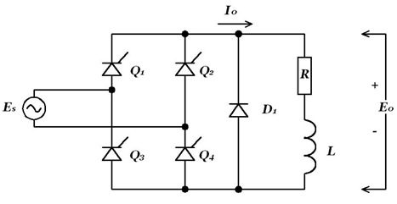

**Figure 6:** One phase thyristor rectifier.

One phase thyristor rectifier gives comparably low voltage to three-phase thyristor rectifier, this will create extensive load to DC-DC converter side, also one phase thyristor bridge requires 4 thyristors, as can be observed from figure 6, while three phase requires just two more (six thyristors in total). Overall circuit is very similar to 3-phase case. The schematic is in the figure 7. Firing angle is set to 0.

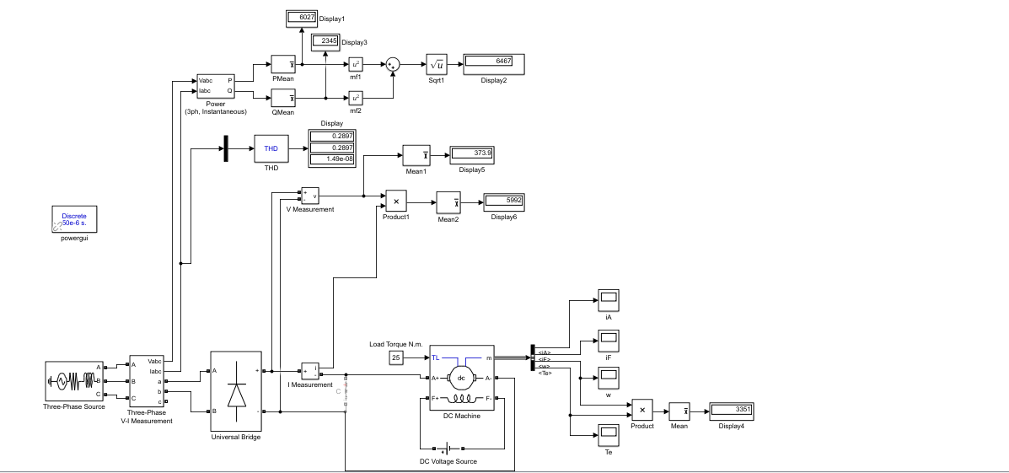

**Figure 7:** 1-ph full controlled rectifier circuit.

Again, since we have decided not to use this configuration only armature current and speed are represented in the following figure 8 & 9.

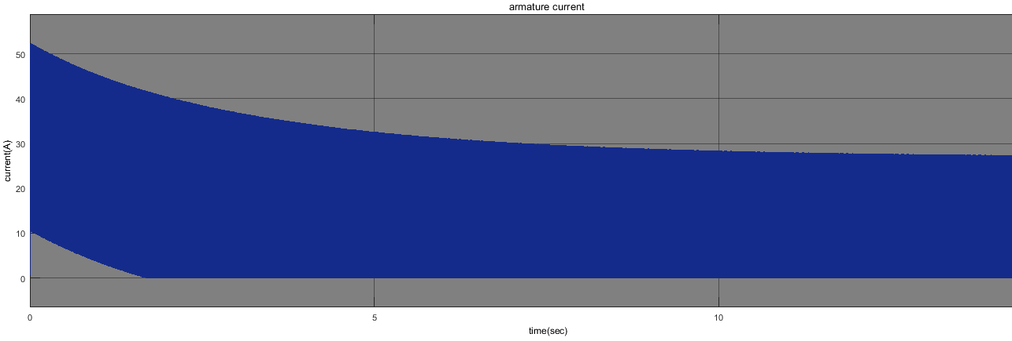

**Figure 8:** Armature current of motor driven by 1-ph full controlled rectifier circuit.

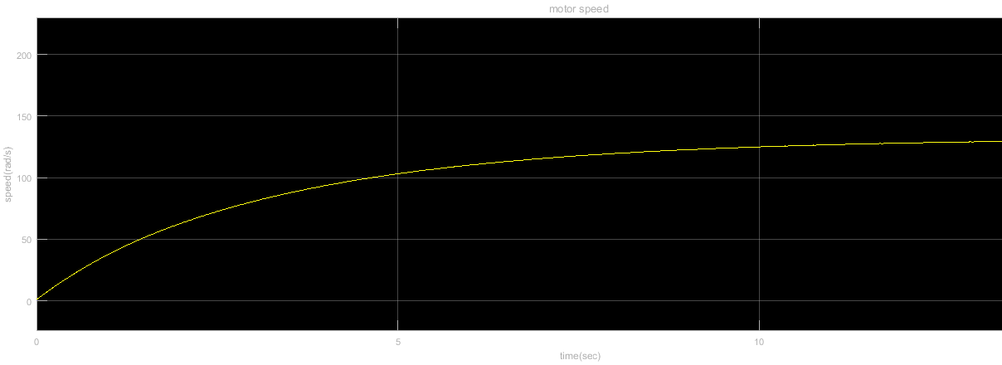

**Figure 9:** Speed of the motor driven by 1-ph full controlled rectifier circuit.

Input current THD is better in this case which is 0.28 and output voltage of the rectifier circuit is 373V. They can be seen from figure 4. One phase thyristor bridge is an alternative topology to three phase thyristor bridge. There is again half and fully controlled variables in 1-phase thyristor bridge. One phase thyristor bridges tend to be cheaper due to lower electronic components than three phase thyristor bridges. This however is overwhelmed by the poor performance compared to three phase thyristor bridge.

One phase thyristors can be used in home appliances where three phases are distributed in a building to different houses or rooms and only one phase is readily available on the sockets. Apart from their cost and ease of use, one phase thyristors are not generally used for high performance applications where three phase thyristors outshine them. As we had three phase readily available to us in our work environment we have decided against using one-phase thyristor rectifier.

### Diode Rectifier (three phase) + Buck Converter

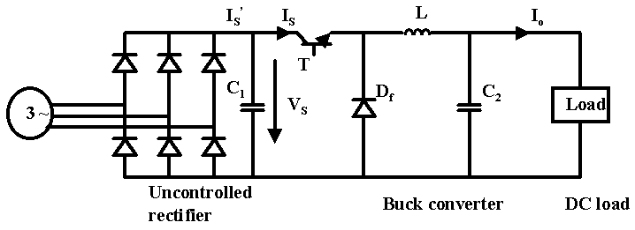

**Figure 10:** Diode rectifier + Buck converter setup.

As can be observed from figure 10, diode bridge is composed of six diodes and output is uncontrolled high ripple DC, while input is AC. This bridge only converts AC to DC and has no control inputs. The control of this setup will be done by the DC-DC converter which is located after the diode bridge.

When we compared diode rectifiers and thyristor rectifiers the main advantage of diodes is not using a gate firing signal. As mentioned before thyristors need gate firing while diode rectifiers turn on with input voltage. Four-quadrant bonus of the project was a critical decision we had to take. Although thyristors are harder operated than diodes, they are easier to generate negative voltages.

Negative voltages can be easily outputted with firing angles greater than 90o. There are however different solutions for four-quadrant operation. One of such solutions include using an H-bridge which basically controls the DC output of the Buck converter. The switching however requires extra attention or high voltages will be shorted and effects can be devastating for the setup.

As EMAchines we have agreed to start by simpler steps and only consider harder bonuses as we achieve important milestones. We have agreed to start with diode bridge as our AC-DC converter. The DC output can be easily converted again in DC with buck converter.

For DC-DC (Buck) converter we require 1 switching element, 1 diode (acting as free wheeling diode) 1 inductor and 1 capacitor. Inductor capacitor pair

## Solution Approach

In order to decide on which topology to choose, we had several things in mind. First of all, we should have decided on which bonuses to attempt. For example, if we wanted to do the "Four quadrant" bonus, we should have chosen a thyristor rectifier topology. However, controlling the thyristors is more complicated than controlling a MOSFET because your circuit also needs to figure out when the input voltage hits zero, then give it a firing angle. This requires a more extensive work on the Arduino coding and a more complicated circuit, increasing the error margin. Risking the whole project on a bonus that we are not certain to achieve did not seem logical to us.

Another thing to consider about the thyristor rectifiers is that due to its seeming more complicated to us, we figured it would take more time to design and implement. Since we were on a deadline, implementing the thyristor rectifier did not look feasible to us. On the other hand, using the diode rectifier-buck converter topology is simpler in our opinion and all of the other bonuses are obtainable with it. The Arduino programming is simple, all we needed to do was give out a variable duty cycle on a higher frequency than Arduino’s 490 Hz frequency. Aside from Arduino, the diode rectifier part is sold as whole, and we didn't need time to put it together and that is a big plus. The buck converter part looked simple enough to implement without error and therefore, we decided to go with the diode rectifier - buck converter topology.

We aim to accomplish the given task with Diode bridge rectifier and Buck converter. Main reason is that implementation of the trigger circuits of the three phase rectifiers are rather harder than trigger circuit of the buck converters which needs simple duty cycle. Second reason is that we planned to design a speed control system under various loads and duty cycle is more convenient to manipulate in a feedback controller system. Although we planned to implement feedback controller we have not finished working on it by the deadline and did not implement the speed controller.

In short, we will convert AC to DC with a 6-pack diode bridge rectifier, put a DC-link capacitor to the output of this bridge. Then we will convert DC to DC with buck converter topology by using a MOSFET as switching element. The freewheeling diode at the buck converter will let the storage elements to discharge into the output. Then we will have a series inductance and parallel capacitance, as a result a low pass filter at the output. Basically, we have a bridge rectifier, two capacitances, a MOSFET, a diode and an inductor. The inductor is wound by us around a core, while other components are bought from commercial distributors.

# SIMULATIONS

## AC-DC Diode Bridge Converter

An AC-DC converter topology given in figure 11.

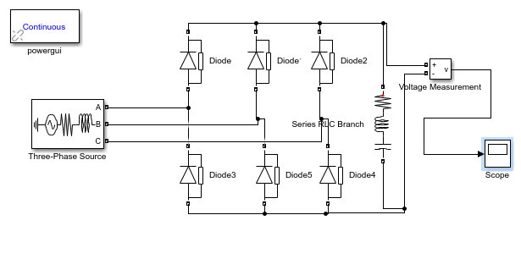

**Figure 11:** AC-DC converter

Output voltage waveform is given in figure 12.

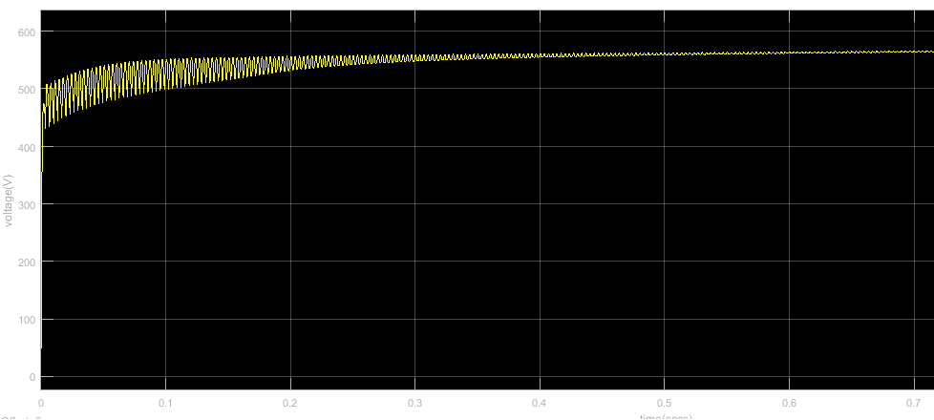

**Figure 12:** Output Voltage Waveform of AC-DC converter

## DC-DC Buck Converter

Buck converter is represented in figure 13.

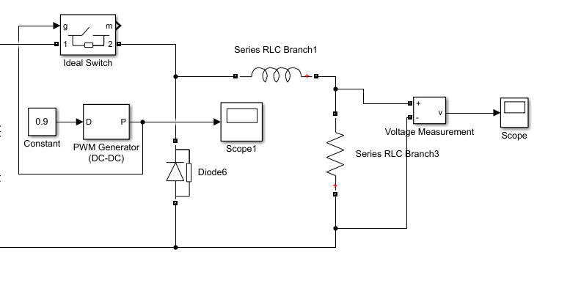

**Figure 13:** Buck converter.

Corresponding output voltages with %90 and %10 duty cycles are in figure 14 and 15 respectively.

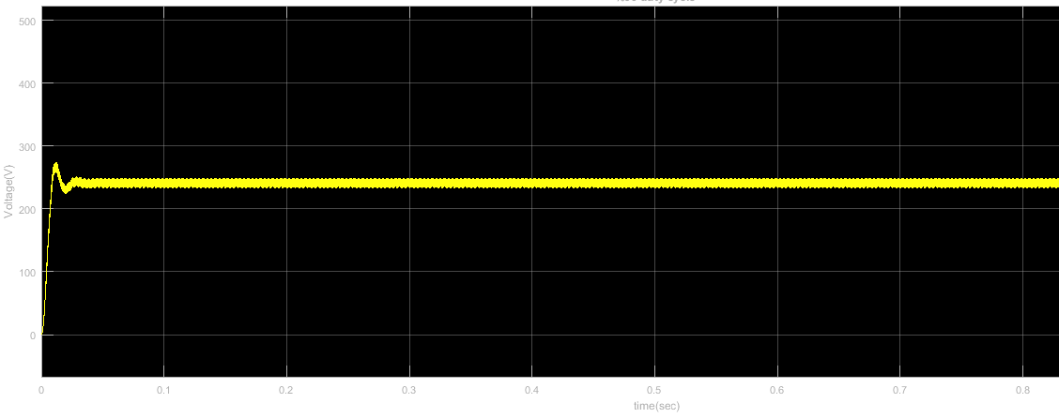

**Figure 14:** %90 duty cycle.

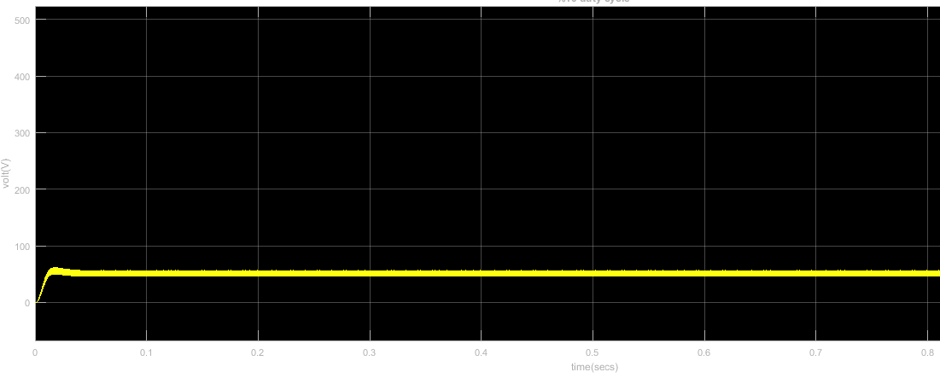

**Figure 15:** %10 duty cycle.

## Overall System Design

As an initial speed of the motor, we adjusted 150 rad/s in the simulations because of some restrictions in simulink software and we connected 25 N/m constant torque on the motor. Our overall circuit is represented in figure 16. Results are obtained with duty cycle %90.

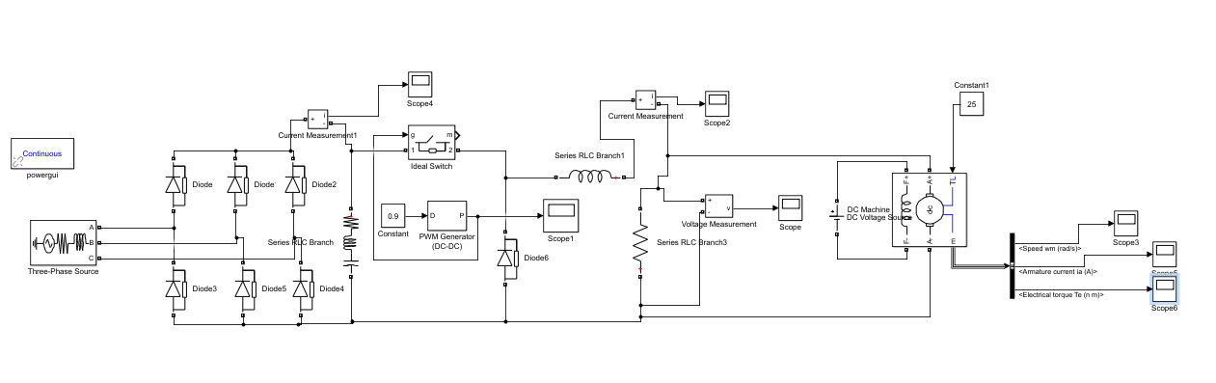

**Figure 16:** Overall circuit

Output current of the rectifier circuit is shown below in figure 17.

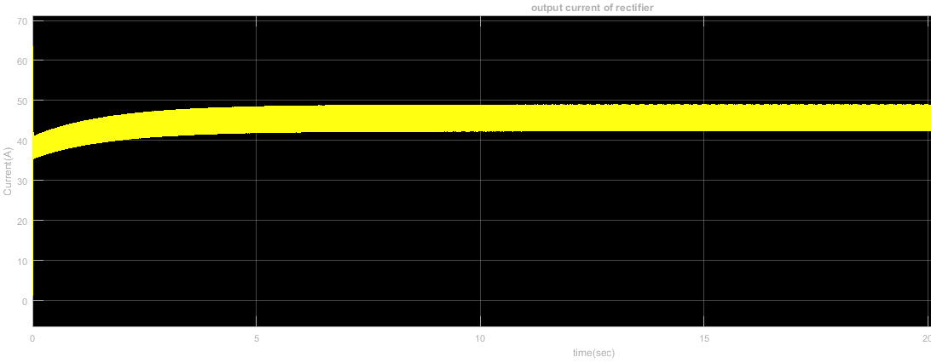

**Figure 17.** Output current of rectifier circuit.

Output voltage and current of buck converter are shown in figure 18 & 19 respectively.

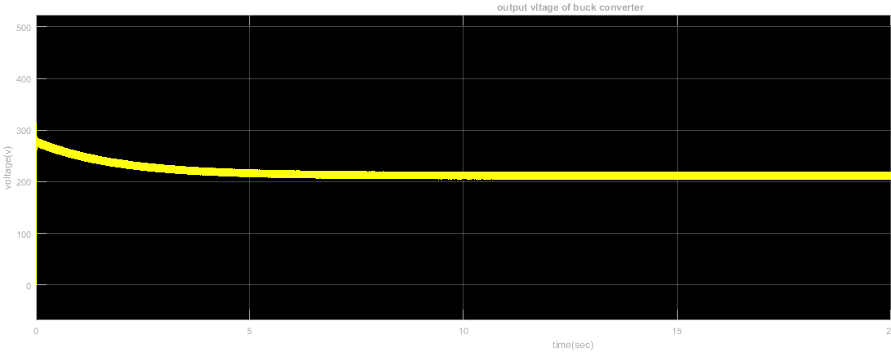

**Figure 18:** Output current of buck converter.

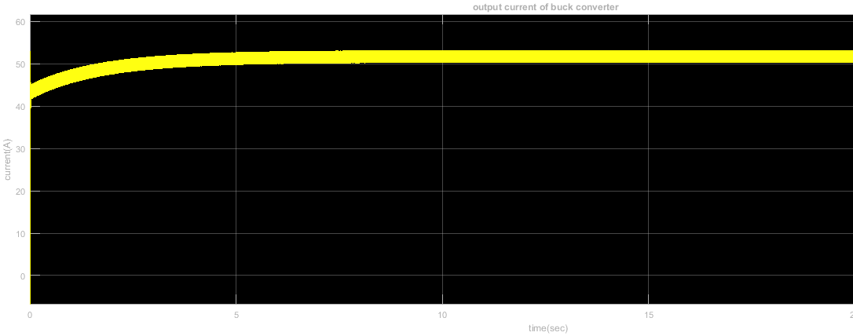

**Figure 19**: Output voltage of buck converter.

Motor measurements are figure 20 & 21.

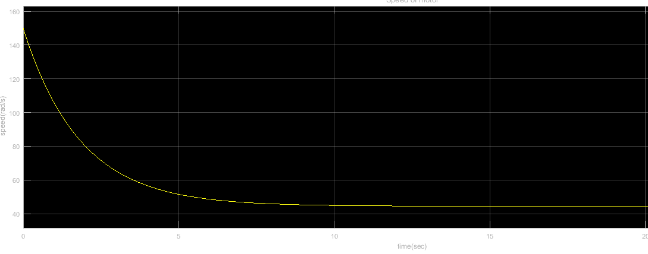

**Figure 20:** Speed of the motor.

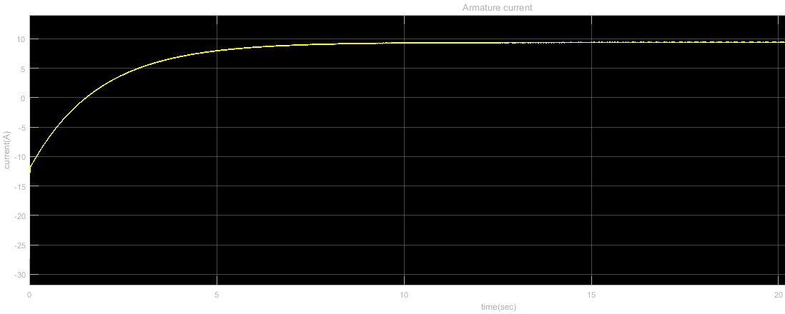

**Figure 21:** Armature current of the motor

In steady state operation, armature current of the motor is approximately 10 A, in the demonstration, we measured it as 12 A. Therefore, our torque constant is approximately equal to the real case in the simulation. Our final speed is almost equal to 40 rad/s. It corresponds to 381 RPM. Armature current and motor speed with duty cycle 30% is shown in figure 22 & 23 respectively.

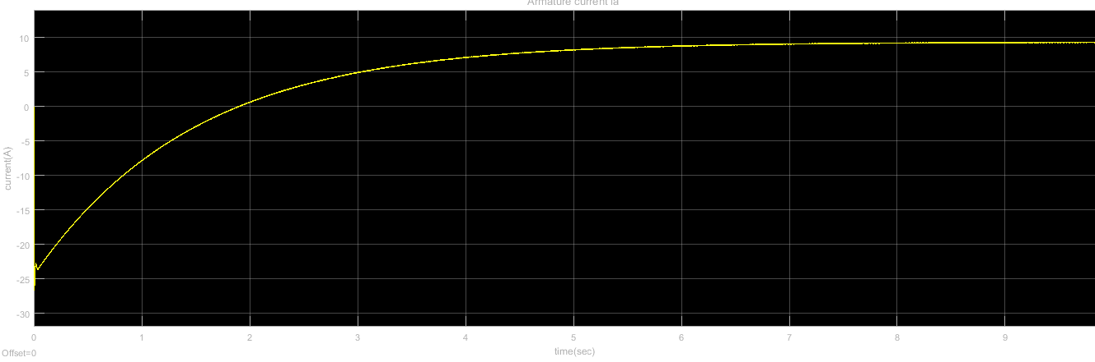

**Figure 22:** Motor armature current with %30 duty cycle.

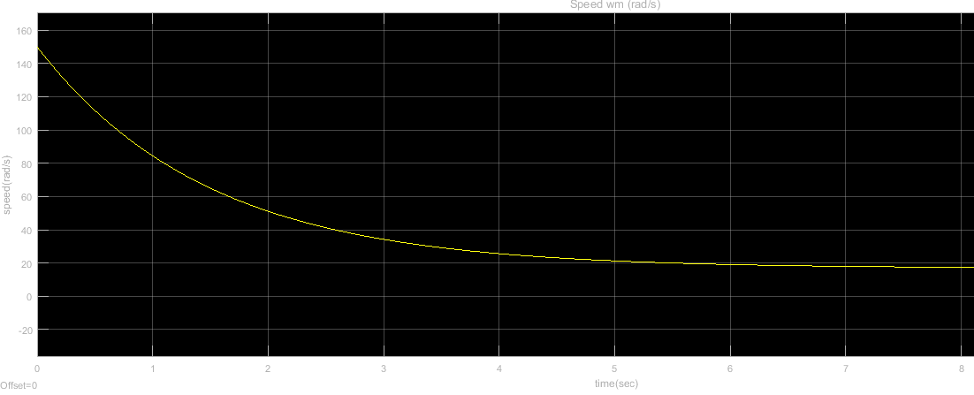

**Figure 23:** Motor speed with %30 duty cycle

## Heat dissipation and Heatsinks

## Filtering Elements and Protection

In case of any fault, high voltage may damage the low voltage equipment and some of this equipment are rather expensive. Therefore, we used TLP250 model optocoupler, as can be seen from figure 24, in order to separate the high voltage and low voltage circuits from each other.

We also used simple DC-link capacitor after AC-DC converter in order to suppress the sudden changes on the voltage value due to voltage drops on the grid line.

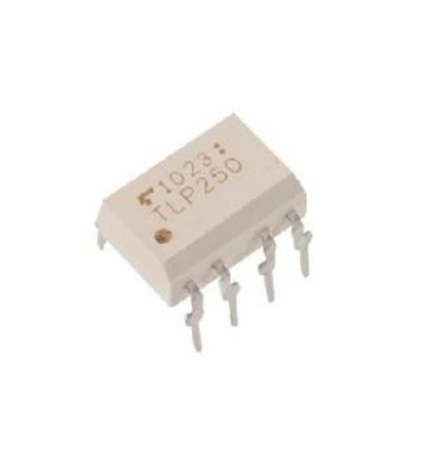

**Figure 24:** TLP250 Optocoupler used to separate high and low voltage circuits

And finally, we have used series inductor and parallel capacitor at the output of the DC side to filter high frequency harmonics, decrease output ripple and eventually improve the overall DC quality.

# TEST RESULTS

We have conducted various tests to make sure that our setup will operate as intended on the demo day. Our testing phase started just after we have bought all required elements and brought them together. We have tested each electronic element and made sure none of them are prematurely faulty. For this purpose, we have measured inductance of our core wound inductor, capacitances of our capacitors, resistances between gates, drains and sources of MOSFETs and resistances of diodes.

When we made sure all of our electronic components were working as intended we started implementing the setup. We have also tested the setup as a whole and the following tests are obtained from the setup.

|  |  |  |
| --- | --- | --- |
|  | Current drawn | Steady State Temp (0C) |
| No-Load | 2A | 30 |
| Half-Load (1.4kW) | 7A | 60 |
| Full-Load (2.8kW) | 12A | N/A (MOSFET Burned) |

**Table 2:** DC motor EMAchines aim to drive.

|  |  |  |
| --- | --- | --- |
| Power and Efficiency | Full Load | Half Load |
| Input Current | 15.4 A | 5.1 A |
| Input Voltage | 145 V | 145 V |
| Input Power | 3.8 kW | 1250 W |
| Output Current | 12.7 A | 5 A |
| Output Voltage | 220V | 220V |
| Output Power | 2.8 kW | 1100 W |
| Power loss | 1kW | 150W |
| Efficiency | 73% | 88% |

**Table 3:** DC motor EMAchines aim to drive.

As can be observed from table 2 there is a proportional relation between current drawn and loading. With no load case we have driven the DC motor with 2 amperes current drawn and we achieved a 300C steady state temperature of our setup. The heatsinks and cooling of our setup is found to be appropriate for no-load case.

Steady state temperature under half-load is found to be 600C, this also showed that heatsinks and cooling of our setup is appropriate for half-load case.

The figure however changed with full loading, as MOSFET heatsink heated up continuously without reaching a steady state temperature it caused a malfunction and sadly our heatsinks and cooling method (natural cooling) was not adequate for full load case.

Inspecting table 3 also gives valuable insights regarding the steady state temperatures. With half loading there is only 150W of heat dissipated from our system in total, with twice the loading (full loading) the heat dissipated is increased sevenfold to 1000Watts. This amount of heat is mainly dissipated from the MOSFET and its heatsink was not been able to withstand this much heating.

# DEMONSTRATION

After testing our setup, we were ready to demonstrate its operation under full load. The setup was fixed inside a plastic box with only three 3-phase AC input cables and 2 output DC cables. These were connected to the variac and DC-motor respectively. The Arduino inside the setup, which was tasked to generate PWM, was fed with a 9Volt zinc-carbon battery and is not directly connected to the high voltage part. In fact, as explained in earlier stages, we have used an optocoupler to separate high and low voltage circuits electrically.

Thanks to the compact box design, we were able to relocate the circuit between testing benches. The potentiometer which was used to control the speed of the motor by adjusting the PWM generated by Arduino is located conveniently outside the box and we were able to change the speed of the motor with a small potentiometer.

## Demonstration Experiences

We were the last group of the demo day and watching all of the other groups burn their circuits had put a lot of stress on us. When it was our turn, we went up to the motor and connected our circuit. We turned on the sources and the motor started rotating. As requested, we went up to full speed and then, we adjusted the speed with our potentiometer. After doing the main objective, we started to test our circuit under load. We also didn't know what was going to happen as we never had the chance to stress test before the demo day.

As the load increased, the current increased and our MOSFET started heating up quickly. Our huge heat sink tried its best to cool down the MOSFET, however, it was not enough. The MOSFET went up to 250 degrees Celsius, and it was holding up quite well until the 7th minute mark. at that point, we lost speed control not because the MOSFET burned down, but because the heat had melted down the soldering on the MOSFET, short circuiting its drain and source. However, at the end, we managed to boil up some water to make tea, which we consider as a success. In order to prevent this, we maybe should have used a bigger heat sink or a powerful fan to cool off the heatsink connected to the MOSFET.

## Heating

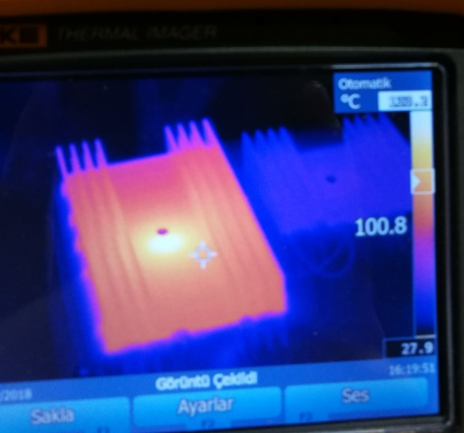 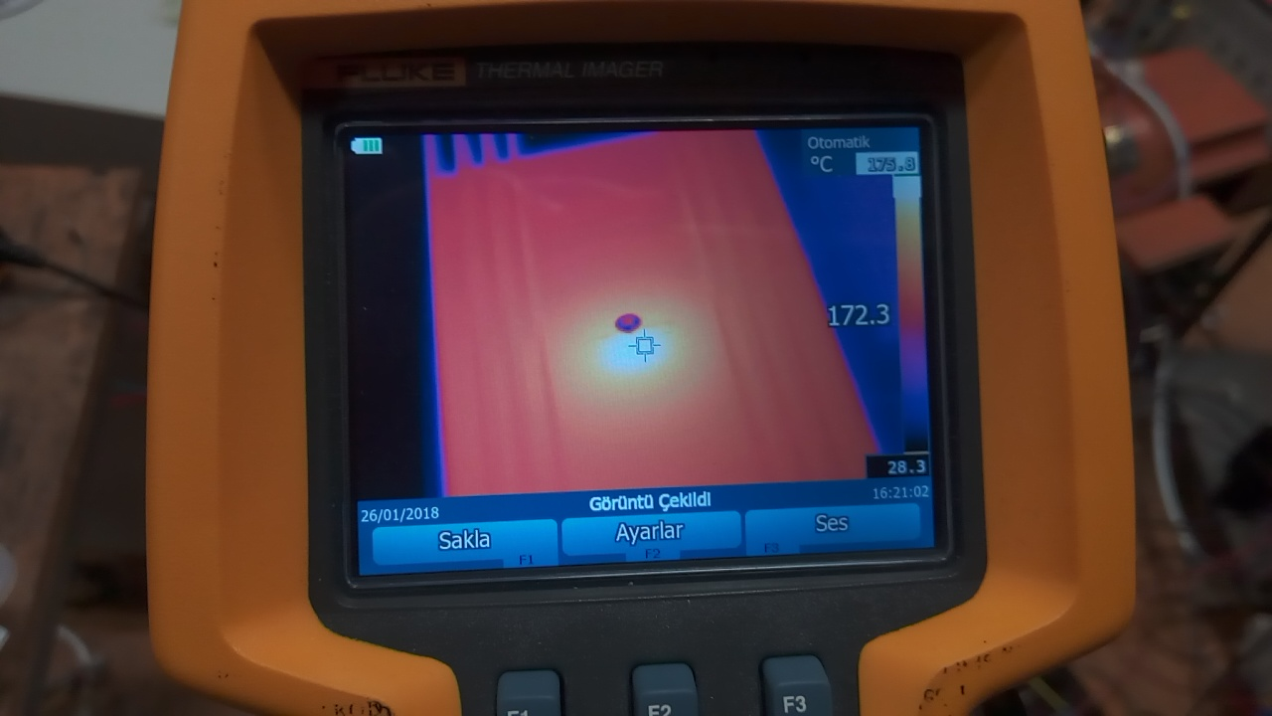

**Figure 25:** Thermal camera screenshots.

During demonstration MOSFET heated extensively, heatsink of MOSFET as can be seen from figure 25 is much hotter than other components and eventually due to extensive heating, the MOSFET’s soldering shorted drain and source.

# EXPANDITURES

We have used 140 TL to design, test and implement this project. The following table contains the main expenditures:

|  |  |
| --- | --- |
| Part | Cost |
| SKBPC3504 Diode Bridge | 1x55₺ |
| IXYS DSEI 30 Fast Diode | 2x8₺ |
| Vishay IRFP460 MOSFET | 2x12₺ |
| 4 Heatsinks | 40₺ |
| Other | 5₺ |
| **Total** | **140₺** |

As can be observed from the table we have bought spare parts for parts considered under risk of volatile burning. Diode bridge rectifier formed the bulk of the expenditures and our initial tests showed that the bridge with its heatsink does not heats above 500C and we have safely discarded the need to buy spare rectifier. However, diode and MOSFET are susceptible to extensive heating due to opening and closing of the circuit and we have bought spare items. With this approach we have implemented and tested our circuit.

When there was less than 24 hours remaining to the deadline our MOSFET stopped working as intended due to an unknown reason. And we have safely replaced it with our spare MOSFET and conducted our tests with the new one. When we measured 30-40 ohms resistances between gate-drain, drain-source and gate-source resistances and this indicated that the MOSFET was burnt and its legs are shorted inside the semiconductor.

# CONCLUSIONS

Overall, this project was quite teaching and fun. We learned the basics of designing a three-phase AC-to-DC converter. along the way, we encountered many difficulties and while getting through them, we learned a lot. During the building process, we had the opportunity to practice our soldering skills, got really familiar with MATLAB SIMULINK during the simulations, learned that we needed huge heat sinks to dissipate the heat that we produce on the MOSFET, when we couldn't drive the MOSFET with the voltage from Arduino, we decided to use optocoupler.

Our design consisted of a three-phase diode rectifier and a cascaded with a buck converter. the diode bridge was quite easy to make because we simply bought it off the market. At the end of the three-phase diode converter, we had a 1 mF capacitor to smoothen the output voltage. after the diode rectifier and the capacitor, we placed the buck converter. The converter used a MOSFET as a switch and it was controlled via a bootleg Arduino Uno. Since Arduino is not enough to provide the required VGS, we used an optocoupler and an outside DC source to obtain the required VGS.

To sum up, we had a chance the to incorporate all the good stuff we learned during the semester into our project and while doing it, we had a lot of fun. We even made tea with the load connected to our motor.

# REFERENCES

1. Keysan, O. (n.d.). Retrieved January 28, 2018, from <http://keysan.me/ee463/>
2. Fitzgerald & Kingsleys electric machinery (7th ed.). New York: McGraw-Hill.
3. Lander, C. W. (1993). Power electronics (3rd ed.). London: McGraw-Hill.
4. Mohan, N., Undeland, T. M., & Robbins, W. P. (2007). Power electronics: converters, applications and design (3rd ed.). New Delhi, India: Wiley India.

# APPENDICES

* 1. Project Trailer Link (in Turkish)

<https://www.youtube.com/watch?v=PyMzq8Eca7o>

* 1. Arduino Code

int potentiometerPin = A2;

void setup()

{ // setup code, to run once:

Serial.begin(9600);

TCCR0B = TCCR0B & 0b11111000 | 0x02;

}

void loop()

{ // main code, to run repeatedly:

int potValue = analogRead(potentiometerPin);

int fadeValue = map(potValue, 0, 1023, 0, 255);

Serial.println(potValue);

analogWrite(6, fadeValue);

delay (10);

}